

oneM2M
Technical Report
Document Number | TR-0028-V0.1.0
Document Name: | Analysis on the interworking between oneM2M and OSGi Alliance
Date: | 2017-04-01
Abstract: | The document investigates on the possible collaboration point between oneM2M and OSGi Alliance.
Template Version: 08 September 2015 (Dot not modify)

This Specification is provided for future development work within oneM2M only. The Partners accept no liability for any use of this Specification.
The present document has not been subject to any approval process by the oneM2M Partners Type 1. Published oneM2M specifications and reports for implementation should be obtained via the oneM2M Partners' Publications Offices.

About oneM2M
The purpose and goal of oneM2M is to develop technical specifications which address the need for a common M2M Service Layer that can be readily embedded within various hardware and software, and relied upon to connect the myriad of devices in the field with M2M application servers worldwide.
More information about oneM2M may be found at: http//www.oneM2M.org
Copyright Notification
© 2015, oneM2M Partners Type 1 (ARIB, ATIS, CCSA, ETSI, TIA, TSDSI, TTA, TTC).
All rights reserved.
The copyright and the foregoing restriction extend to reproduction in all media.

Notice of Disclaimer & Limitation of Liability
The information provided in this document is directed solely to professionals who have the appropriate degree of experience to understand and interpret its contents in accordance with generally accepted engineering or other professional standards and applicable regulations. No recommendation as to products or vendors is made or should be implied.
NO REPRESENTATION OR WARRANTY IS MADE THAT THE INFORMATION IS TECHNICALLY ACCURATE OR SUFFICIENT OR CONFORMS TO ANY STATUTE, GOVERNMENTAL RULE OR REGULATION, AND FURTHER, NO REPRESENTATION OR WARRANTY IS MADE OF MERCHANTABILITY OR FITNESS FOR ANY PARTICULAR PURPOSE OR AGAINST INFRINGEMENT OF INTELLECTUAL PROPERTY RIGHTS. NO oneM2M PARTNER TYPE 1 SHALL BE LIABLE, BEYOND THE AMOUNT OF ANY SUM RECEIVED IN PAYMENT BY THAT PARTNER FOR THIS DOCUMENT, WITH RESPECT TO ANY CLAIM, AND IN NO EVENT SHALL oneM2M BE LIABLE FOR LOST PROFITS OR OTHER INCIDENTAL OR CONSEQUENTIAL DAMAGES. oneM2M EXPRESSLY ADVISES ANY AND ALL USE OF OR RELIANCE UPON THIS INFORMATION PROVIDED IN THIS DOCUMENT IS AT THE RISK OF THE USER.

Contents
Contents 3
1 Scope 4
2 References 4
2.1 Normative references 4
2.2 Informative references 4
3 Definitions, symbols and abbreviations 4
3.1 Definitions 4
3.2 Symbols 5
3.3 Abbreviations 5
4 Conventions, 5
5 Introduction to OSGi Framework 5
6 Service layer API binding 6
6.1 Requirement description 6
6.2 Potential solution and focus of oneM2M 6
7 Protocol binding using OSGi 7
7.1 Requirement description 7
7.2 Potential solution and focus of oneM2M 7
8 oneM2M-OSGi Interworking 7
8.1 Requirement description 7
8.2 Potential solution and focus of oneM2M 7
8.2.1 General architecture 7
8.2.2 Registration 8
8.2.3 Data Management and Repositary 8
8.2.4 Subscription 8
8.2.5 Device Management 8
9 Information model mapping 9
9.1 Requirement description 9
9.2 Potential solution and focus of oneM2M 9
Proforma copyright release text block 9
Annexes 9
Annex <y>: Bibliography 10
History 10

1 Scope
The present document provides an analysis of the possible collaboration points between oneM2M and OSGi alliance. The analysis includes brief introduction to OSGi alliance, requirements of the collaboration and potential methods of achieving the requirements. The present TR also analyses the focus of oneM2M in the collaboration.
EXAMPLE: The present document provides the necessary adaptions to the endorsed document.
The Scope shall not contain requirements.

2 References
The following text block applies.
References are either specific (identified by date of publication and/or edition number or version number) or non-specific. For specific references,only the cited version applies. For non-specific references, the latest version of the referenced document (including any amendments) applies.

2.1 Normative references
As a Technical Report (TR) is entirely informative it shall not list normative references.
The following referenced documents are necessary for the application of the present document.
Not applicable.

2.2 Informative references
Clause 2.2 shall only contain informative references which are cited in the document itself.
The following referenced documents are not necessary for the application of the present document but they assist the user with regard to a particular subject area.
[i.1] oneM2M Drafting Rules (http://www.onem2m.org/images/files/oneM2M-Drafting-Rules.pdf)
[i.2] OSGi Residential (https://www.osgi.org/developer/downloads/release-6/)
[i.3] OSGi Core (https://www.osgi.org/developer/downloads/release-6/)

3 Definitions, symbols and abbreviations
Delete from the above heading the word(s) which is/are not applicable.

3.1 Definitions
Clause numbering depends on applicability.
- A definition shall not take the form of, or contain, a requirement.
- The form of a definition shall be such that it can replace the term in context. Additional information shall be given only in the form of examples or notes (see below).
- The terms and definitions shall be presented in alphabetical order.
For the purposes of the present document, the [following] terms and definitions [given in ... and the following] apply:
Definition format
<defined term>: <definition>
If a definition is taken from an external source, use the format below where [N] identifies the external document which must be listed in Section 2 References.
<defined term>[N]: <definition>
example 1: text used to clarify abstract rules by applying them literally
NOTE: This may contain additional information.

3.2 Symbols
Clause numbering depends on applicability.
For the purposes of the present document, the [following] symbols [given in ... and the following] apply:
Symbol format
<symbol> <Explanation>
<2nd symbol> <2nd Explanation>
<3rd symbol> <3rd Explanation>

3.3 Abbreviations
Abbreviations should be ordered alphabetically.
Clause numbering depends on applicability.
For the purposes of the present document, the [following] abbreviations [given in ... and the following] apply:
Abbreviation format
ARIB Association of Radio Industries and Businesses
ATIS Alliance for Telecommunications Industry Solutions
CCSA China Communications Standards Association
ETSI European Telecommunications Standards Institute
TIA Telecommunications Industry Association,
TSDSI Telecommunications Standards Development Society
TTA Telecommunications Technology Association
TTC Telecommunication Technology Committee
<ABBREVIATION1> <Explanation>
<ABBREVIATION2> <Explanation>
<ABBREVIATION3> <Explanation>

4 Conventions,
The key words “Shall”, ”Shall not”, “May”, ”Need not”, “Should”, ”Should not” in this document are to be interpreted as described in the oneM2M Drafting Rules [i.1]

5 Introduction to OSGi Framework
The OSGi framework is the infrastructure and platform to enable the modularization and componentization of bundles built on top of JAVA technology. [i.3]
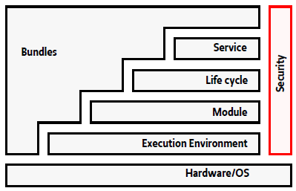
Figure 5.1-1: OSGi Framework[i.3]
Editor’s note: the copyright issue of copying the figure need to be checked and updated correspondingly.
Bundle is the core of OSGi framework, it is the smallest unit of modularization. An OSGi bundle is composed of Java classes and resources which provides or consumes services with each other using uniformed way defined by OSGi. The life cycle of bundle is also managed by OSGi we defined manner that any bundle could easily be started, stoped or updated dynamically without the rebooting of the whole framework.
The OSGi Framework is composed of the following layers:
Security Layer: is based on Java 2 security but does some enhancements to Java by adding constraints and new features.
Module Layer: is the core of the modularization in OSGi. It defines rules for sharing Java packages between bundles or hiding packages from other bundles. The Life Cycle Layer and Service Layer is built on top of Module Layer.
Life cycle Layer: provides an API to manage the bundles in the Module Layer. It defines how bundles are started and stopped as well as how bundles are installed, updated and uninstalled.
Service Layer: provides a communication model for the bundles. The service layer provides a programming model for Java bundle developers to simplify the development and deployment of service bundles by de-coupling the service's specification from its implementations.
OSGi at the same time defines services based on the layered framework. The services defined in [i.2] is about the service that can be provided in residential domain which is the major task of OSGi interworking.

6 Service layer API binding

6.1 Requirement description
The clause describes the purpose and scope of the collaboration direction.

6.2 Potential solution and focus of oneM2M
The clause describes the potential solution and the focus of oneM2M i.e. which part of the job should be done in oneM2M? How to divide the job between two organizations?

7 Protocol binding using OSGi

7.1 Requirement description

7.2 Potential solution and focus of oneM2M

8 oneM2M-OSGi Interworking

8.1 Requirement description
OSGi Alliance defines services and interfaces for devices and functions provided by the devices[i.2]. Applications could utilize these services and interfaces to manipulate the device or read data from the device. End to end use cases and solutions can be produced in this way. The main purpose of oneM2M-OSGi Interworking is to enable the mutual service discovery and exposure of both standards. Which is to say, services and interfaces defined by OSGi can be mapped to oneM2M defined resources, and mutually, oneM2M defined resources can be mapped to OSGi defined services and interfaces. In this way, any OSGi compliant devices can be connected seamlessly to oneM2M system and viewed as a typical oneM2M entity by oneM2M defined CSEs and AEs. And vice versa, oneM2M compliant entities can be connected with OSGi devices as well. From the perspective of OSGi devices, oneM2M Entities are exposing OSGi defined services and interfaces.
OSGi Device
oneM2M Entity
Figure 8.1-1: oneM2M-OSGi Interworking requirement

8.2 Potential solution and focus of oneM2M

8.2.1 General architecture
In order to achieve the requirements, an oneM2M-OSGi Interworking Bundle need to be defined. The service is in charge of all the mapping and translation of OSGi service and oneM2M resource.
The oneM2M-OSGi Interworking Bundle is running on the same OSGi Framework with the other OSGi services as well as the CSE Bundle that is implemented following the oneM2M specification.
From the OSGi perspective, the oneM2M-OSGi Interworking Bundle is defined as a Service with interfaces translated from oneM2M resource structures.
From the oneM2M perspective, the oneM2M-OSGi Interworking Bundle is defined with the purpose of mutual translation of OSGi services and oneM2M resource. The oneM2M-OSGi Interworking Bundle connects with a Common Services Entity (CSE) to expose all OSGi services using oneM2M resources.
It’s well recognized that not all OSGi service and oneM2M resource may have one-to-one mapping. Some OSGi service may result in vancant oneM2M resources or procedures and vice versa. Some OSGi service may result in a combination of oneM2M resources and procedures and vise versa.The intention of the interworking to try to address to the best effort the largest common set of shared services.
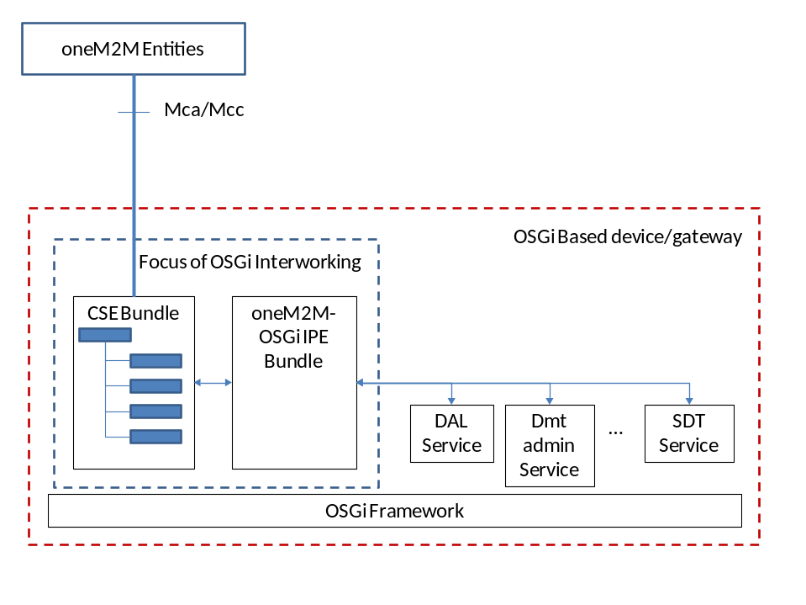
Figure 8.2.1-1: oneM2M-OSGi Interworking architecture

8.2.2 Registration
The REG CSF of oneM2M is interworked with DAL (Device Abstraction Layer) in OSGi.
Editor’s Note: Detailes need to be further finalized.

8.2.3 Data Management and Repositary
The DMR CSF of oneM2M is interworked with DAL (Device Abstraction Layer) in OSGi.
Editor’s Note: Detailes need to be further finalized.

8.2.4 Subscription
The SUB CSF of oneM2M is interworked with DAL (Device Abstraction Layer) in OSGi.
Editor’s Note: Detailes need to be further finalized.

8.2.5 Device Management
The DMG CSF of oneM2M is interworked with Dmt Admin Service in OSGi.
Editor’s Note: Detailes need to be further finalized.

9 Information model mapping

9.1 Requirement description

9.2 Potential solution and focus of oneM2M
The following text is to be used when appropriate:

Proforma copyright release text block
This text box shall immediately follow after the heading of an element (i.e. clause or annex) containing a proforma or template which is intended to be copied by the user. Such an element shall always start on a new page.
Notwithstanding the provisions of the copyright clause related to the text of the present document, oneM2M grants that users of the present document may freely reproduce the <proformatype> proforma in this {clause|annex} so that it can be used for its intended purposes and may further publish the completed <proformatype>.
<PAGE BREAK>

Annexes
Each annex shall start on a new page (insert a page break between annexes A and B, annexes B and C, etc.).
Use the Heading 9 style for the title and the Normal style for the text.
Annex <A>:
Title of annex (style H9)
<Text>
<PAGE BREAK>
Annex <B>:
Title of annex (style H9)
<Text>
B.1 First clause of the annex (style H1)
<Text>
B.1.1 First subdivided clause of the annex (style H2)
<Text>
<PAGE BREAK>

Annex <y>:
Bibliography
The annex entitled "Bibliography" is optional.
It shall contain a list of standards, books, articles, or other sources on a particular subject which are not mentioned in the document itself.
It shall not include references mentioned in the document.
Use the Heading 9 style for the title and B1+ or Normal for the text.
- <Publication>: "<Title>".
OR
<Publication>: "<Title>".
<PAGE BREAK>

History
This clause shall be the last one in the document and list the main phases (all additional information will be removed at the publication stage).
Publication history
V.1.1.1 | <dd Mmm yyyy> | <Milestone>

Draft history (to be removed on publication)
V.0.0.1 | 11 July 2016 | Skeleton
V0.1.0 | 1 April 2017 | Incorporated contributions:  ARC-2017-0127R02-TR_0028_introduction  ARC-2017-0128R02-TR_0028_OSGi_interworking

